After getting the sentimental scores, we want to test whether they can help to improve the model to forest TESLA stock return. We used four kinds of feature sets in this step. The four kinds of feature sets are:

1. Base. Use last day volume and last day Nasdaq index return.
2. Vader. Add compound score to Base.
3. NB. Add positive, negative, neutral scores to Base.
4. All. All NB, Vader, Base features together.

We split the who data set into 144 train samples and 48 test samples.

For the linear model, we select the Ridge model. To select the best alpha in the Ridge model, we used rolling validation to find the alpha which maximizes the RMSE in the validation set to be as alpha. Rolling validation can be illustrated in the following graph:

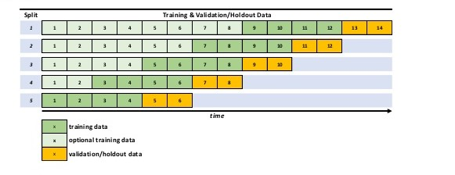

For the time-series data, we must use rolling validation rather than cross-validation, which will cause looking ahead bias. In the graph above, we can see that we select a time window to train, and use another time window as validation. After this sample, we move to the start point of the training set forward and generate another sample. This is rolling validation.

For the ridge data, we find the graph for alpha is as below:

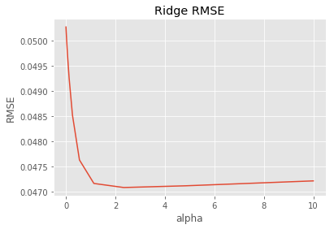

Therefore, the best alpha to achieve a stable lowest RMSE is at 2.3357.

Use this best alpha and train model at training set, then test the result at test set, we get the RMSE of four feature sets as below:

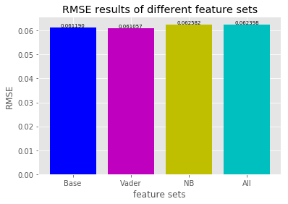

We can find that:

1. Vader achieves a lower RMSE than Base, so the compound score using the Vader method does help to improve stock return prediction for TESLA.
2. NB and All get higher RMSEs than Base, so the positive, negative, neutral scores using the Naïve Bayesian method don’t help to improve stock return prediction for TESLA.